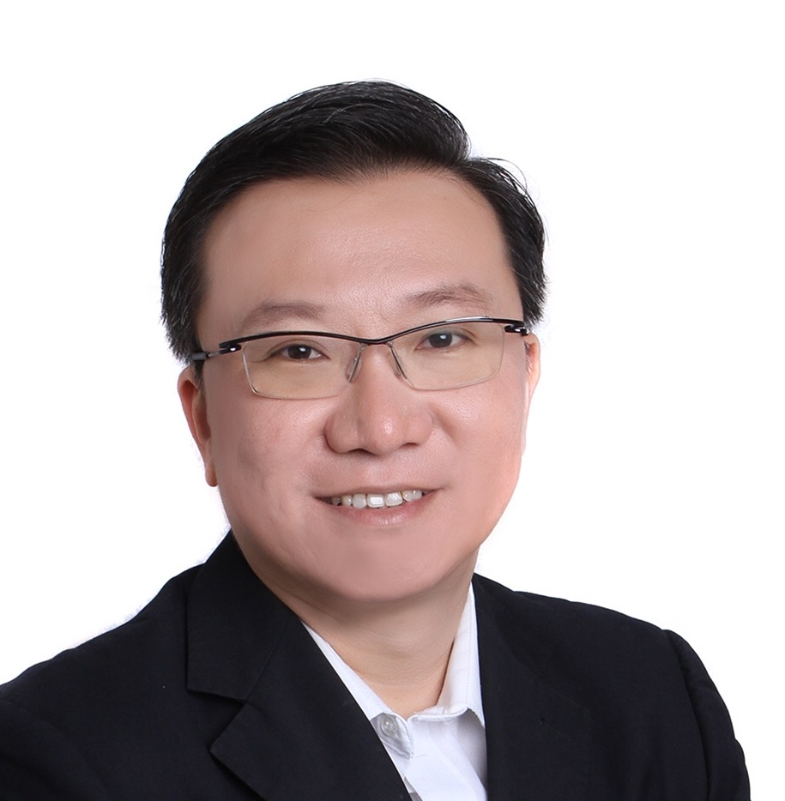

**Wee Eng Hin**

Senior Director / Principal IT Architect

**RESUME (Jul 2023)**

I am interested in role with leadership responsibilities in delivering high-tech ICT services with strategic business impact to the organisation and its customers.

C444

1. Lead solution team in pre-sales bids, architecture designs and proposals
2. Responsible for financial performance, business growth, customer engagement and staff management of a delivery centre
3. Manage post-sales ICT project delivery & outsourcing services for large enterprises

**CURRENT ROLE**

**Personal Info**

**Contact**

**NCS PTE LTD :-**

**2019 – Current :** Senior Director / Principal IT Architect

**2010 – 2018 :** Service Delivery Director / Practice Lead

**2000 – 2009 :** Senior Manager / Solution Architect

**1994 – 1999 :** Network Consultant

**EMPLOYMENT**

**Awards & Recognitions**

* **Best Leader Award**
* **CEO Excellence Award**
* **Singtel Excellence Award**
* **NCS Service Excellence Award**
* **NCS Difference Quality Award**
* **25-year Long Service Award**
* **Program Management Professional (PgMP)**
* **Professional Agile Leader (PAL)**
* **Project Management Professional (PMP)**
* **AWS Cloud Practitioner**
* **Azure Cloud Fundamentals**
* **ITIL v3 Expert (ITSM)**
* **Senior Certified IT Project Manager (Snr CITPM)**
* **Senior Certified Outsourcing Manager for IT (Snr COMIT)**
* **Cisco Certified Internetworking Expert (CCIE) Lifetime Emeritus**
* **SABSA Chartered Security Architect (SCF)**

**Professional Certifications**

**: +65 9735 0754**

**: weeenghin@gmail.com**

**: linkedin.com/in/weeenghin**



**Nationality : Malaysian / Spore PR**

**MEMBERSHIP**

**Senior Member, Singapore Computer Society**

**Member, Project Management Institute**

**EDUCATION**

**1990 – 1993 : Curtin University of Technology, Australia**

**B.Sc (Computer Science) (1st Class Honours)**

**2004 : INSEAD, Singapore / France**

**Young Managers Programme (YMP)**

**KEY RESPONSIBILITIES**

* Lead the pre-sales solutioning team in sales proposal and tenders, especially in ICT architecture design, technical solution, security compliance and operation-model
* Manage and develop pool of staff (architects, project managers, engineers) to meet business needs and deliver superior customer experience
* Responsible for business growth and managing P&L to meet financial KPI of a delivery centre
* Manage and build good rapport with customers and stakeholders (internal and external) including C-level executives
* Lead any assigned corporate initiatives, such as digitalisation and automation
* Manage portfolio of projects concurrently for successful post-sales delivery and smooth operations – within timeline, costs, resources and scope
* Manage customers’ senior management expectations to achieve a win-win situation for long-term partnership
* Manage crisis situation with delivery teams to provide prompt workaround solution or resolution for customers

**MAJOR PROJECTS**

|  |  |  |
| --- | --- | --- |
| **Project 1** | **:** | **Data Centre & Cloud Strategy, Architecture and Migration Programme** |
| **Project Size** | : | Multi-year base contracts with extensions approx 300 staff |
| **Services Provided** | : | Design, implementation, provision and management of IT infrastructure & services in new Data Centers for Singapore Government, including service migrations from previous Data Centers. The IT services are provided to over 60,000 users and 95 agencies. |
| **Period** | : | Programme duration is 2013-2024 (new contract #2 awarded in 2019) |
| **Role** | : | Principal IT Architect |
| **Accomplishments** | : | Successfully designed and completed the IT infrastructure implementation in 2 Data Centre within a year, including migration of key IT services. Led the operations team in day-to-day IT support that meets stringent Service Level Agreements (SLA). |
| **Project 2** | **:** | **Government-wide Core IT Infrastructure Programme** |
| **Project Size** | : | Multi-year base contracts with extensions approx 300 staff |
| **Services Provided** | : | Design, implementation, provision and management of IT infrastructure & services in new Data Centers for Singapore Government, including service migrations from previous Data Centers. The IT services are provided to over 60,000 users and 95 agencies. |
| **Period** | : | Programme duration is 2013-2024 (new contract #2 awarded in 2019) |
| **Role** | : | Service Delivery Director & Chief Architect |
| **Accomplishments** | : | Successfully designed and completed the IT infrastructure implementation in 2 Data Centre within a year, including migration of key IT services. Led the operations team in day-to-day IT support that meets stringent Service Level Agreements (SLA). |
| **Project 3** | **:** | **Schools ICT Standard Operating Environment (SSOE) Programme** |
| **Project Size** | : | 8 years base contract, approx. 800 staff |
| **Services Provided** | : | Design, implementation, provision and management of over 120,000 desktops, network, servers, Data Centers and wide range of IT services to 40,000 teachers & administrative staff and 500,000 students from 360 primary, secondary schools and junior colleges under Ministry of Education (MOE), Singapore. The key IT services include Active Directory service, File service, Security service, Network service, Enterprise management service, Data Centre operations and Remote Access service. |
| **Period** | : | Programme duration is 2010-2025 (new contract #2 awarded in 2017) |
| **Role** | : | Programme Director & Chief Architect |
| **Accomplishments** | : | Successfully designed and completed the implementation of complex enterprise IT infrastructure and services in 2 Data Centre infrastructure within a year and completed 120,000 desktop rollout within two years. This project won several IT Industry awards, including IT Excellence and SiTF awards in 2012. |

|  |  |  |
| --- | --- | --- |
| **Project 4** | **:** | **Provision of IT Outsourcing Services** |
| **Project Size** | : | 10 years contract, approx 90 staff |
| **Services Provided** | : | Comprehensive IT support services for customer, including Service Desk and day-to-day operations of its two Data Centers. |
| **Period** | : | 2002 – 2012 |
| **Role** | : | Project Director / Project Manager |
| **Accomplishments** | : | Managed to takeover successfully the large and complex IT operations from previous provider within 3 months. Managed to meet key customer service level agreement (SLA) consistently, including the annual customer satisfaction survey. After year 5, won a new contract to provide support for another 5 years. Obtained ISO20000 certification for this project. |

|  |  |  |
| --- | --- | --- |
| **Project 5** | **:** | **Consultancy Service for IT Improvement for a Telecommunication service provider in Philippines** |
| **Project Size** | : | Approx 10 consultants |
| **Services Provided** | : | IT assessment study (in areas like IT Service Management Processes, IT Service Management Tools, Service Desk Processes) and review of IT Operations (in areas like Database Administration, System Administration and Production Control & Operations)  The key deliverable was an assessment report documenting the assessment findings, recommendations and proposed improvement projects. |
| **Period** | : | 2008- 2009 |
| **Role** | : | Lead Consultant & Project Manager |
| **Accomplishments** | : | Successfully led the consulting team in completing the assessment and study report on schedule. Customer accepted the recommendations by initiating new IT projects. |